**MATLAB Project #2**

**Date Submitted: March 25, 2014**

**Group 3:**

Daniel Noyse  
Brandyn Fastino

Cullen Fahey

Jenny Doan

ECE 321

Continuous Time Linear Systems

Karen Payton

Spring 2014

Table of Contents

Introduction 3

Plots 3

Part 1: 3

Part 2: 8

Answers to the Questions 9

1. What difference(s) did you notice between the 2-period time plots of the pure tone at 440 Hz, the tone with harmonics added at equal amplitudes and the tone with harmonics at decreasing amplitudes? 9

2. What is the mathematical expression for the exponential decaying note in Part 1? 9

3. Describe how the sound of the clar_melody differed from the first project due to the added harmonics. 9

4. What other modifications can you think of that might make a melody sound more natural? 10

Conclusion 10

# Introduction

[Section by Brandyn Fastino]

The second Matlab project required the group to modify the spectral characteristics of the melody we generated in Project 1. This project was broken up into two parts. The first part is to generate harmonics to add onto the melody that we created in the first project. The second part is synthesizing our melody to sound like a clarinet is playing. Doing all these parts make adds more segments and variation to our melody.

# Plots

[Section by Jenny Doan]

## Part 1:

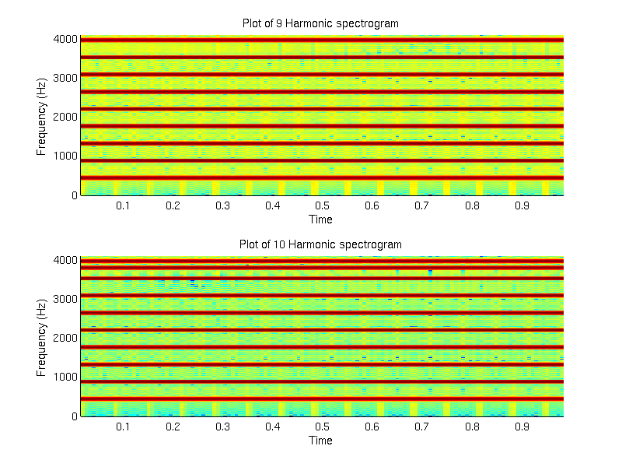

**What would happen if you tried to add a 10th harmonic?**

When you add a 10th harmonic, the harmonics is supposed to get softer as more harmonics are added on and we saw that as we tested the sound of the added harmonic.

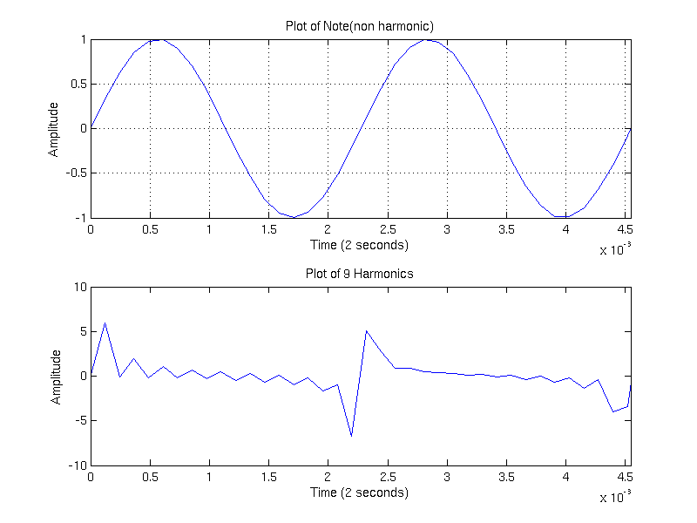

**What effect did adding the harmonics have on the waveform?**

When more harmonics are added, the sine wave becomes less and less like a triangle wave and more and more like a triangle wave.

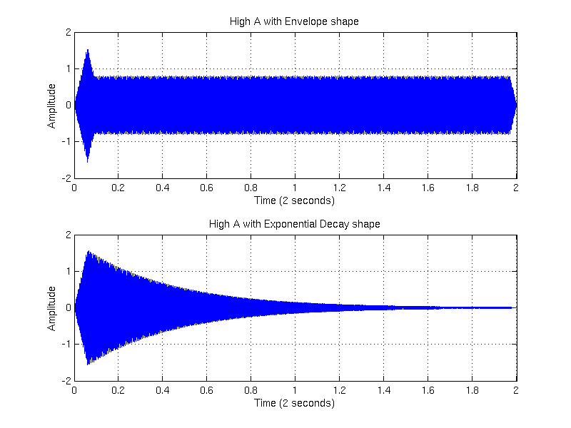

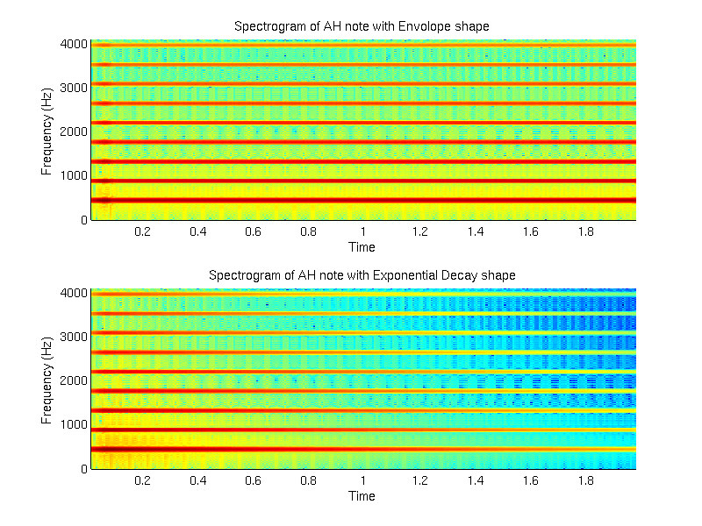

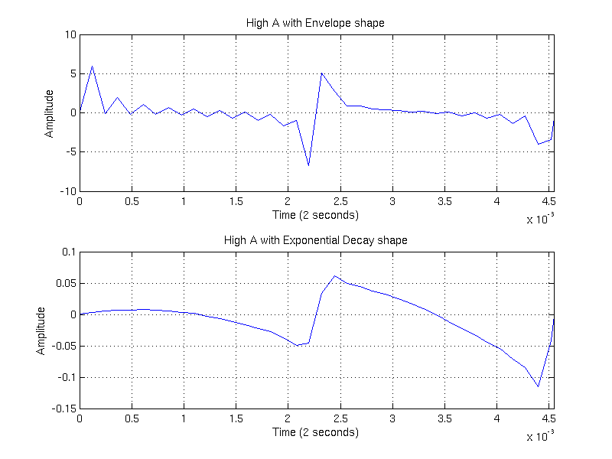

**What affect did changing A_vect have on the waveform?**

As more harmonics are added, the amplitude is decreased exponentially.

## Part 2:

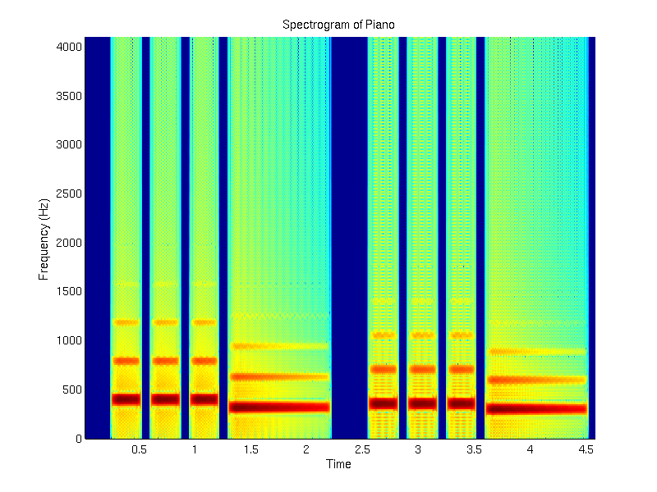

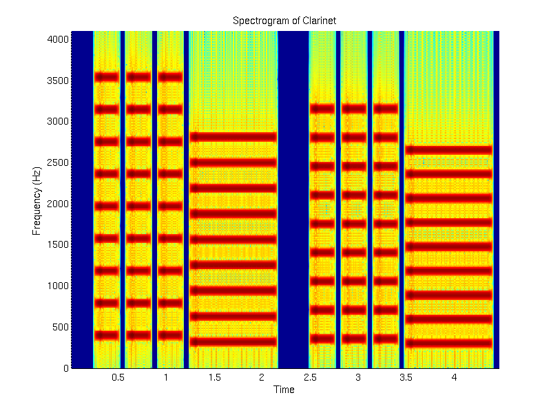

# Answers to the Questions

[Section by Cullen Fahey]

## 1. What difference(s) did you notice between the 2-period time plots of the pure tone at 440 Hz, the tone with harmonics added at equal amplitudes and the tone with harmonics at decreasing amplitudes?

The 2-period time plots of the pure tone differ with an added harmonic doesn’t sound natural or fluid. The Tone with the added harmonics is softer sounding than the pure tone and is shown in the graph as well. The tone with harmonics at decreasing amplitudes sounds the most natural and fluid of the three due to the harmonics decreasing.

## 2. What is the mathematical expression for the exponential decaying note in Part 1?

Sin (2*pi*F*T) * e^(-t/τ)

## 3. Describe how the sound of the clar_melody differed from the first project due to the added harmonics.

The added harmonics created a softer more natural sound because it creates a more natural decay of the tone instead of a uniform decay creating a better audio affect.

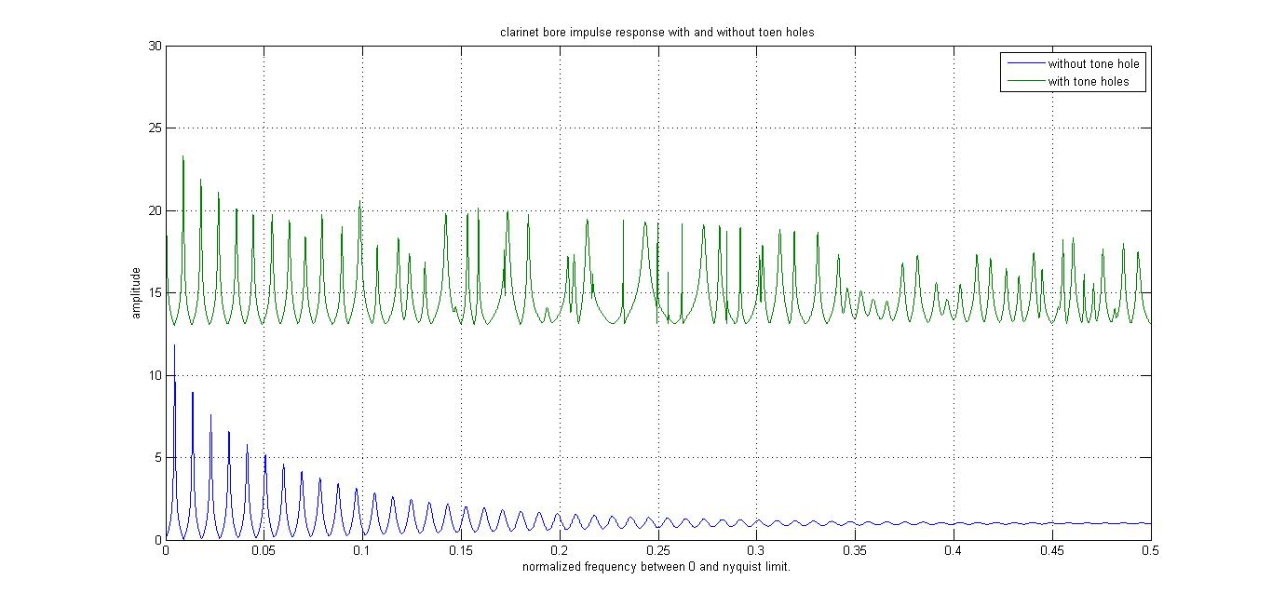

Notice how in the above figure, the note still decays with harmonics but it has a more natural look to it

## 4. What other modifications can you think of that might make a melody sound more natural?

Some additional modifications that could be done to make the melody sound more natural are to lengthen, shorten, or remove the pauses after the notes. Other methods include adding contours or echoing the notes.

# Conclusion

[Section by Daniel Noyes]

This particular project’s goal was to use the Fourier series to add on to our melody from project 1. Adding on to our project, we had to generate different harmonics for different instruments because different instruments have different harmonic structures. For the harmonics, the fundamental frequency is almost always the strongest so you need to make the harmonics softer as the harmonic number increases. We tested different harmonics and compared them all. The second part to this project is to synthesize the melody so it sounds more like a piano. In order to accomplish this task, we needed to use an exponential decay. Finally, to make our melody sound better, we manipulated the pauses at the end of each note.